Generated Report:

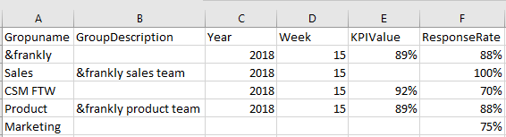

This is how the output report looks like. There are some missing fields, and this document is going to explain why that happened.

Sales.KPIValue

It is not in the <https://data.api.andfrankly.com/v1/kpis/P-100/values?groupId=3939&includeSubgroups=true> service response :

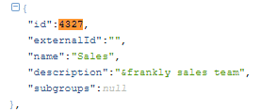

Sales is the group with id 4327 and the groupKpi service returns

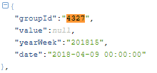

Sales.KPIValue is null.

Marketing.Year, Marketing.Week, Marketing.KPIValue

They are not in the <https://data.api.andfrankly.com/v1/kpis/P-100/values?groupId=3939&includeSubgroups=true> service response

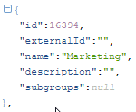

Marketing is the group with id 16394

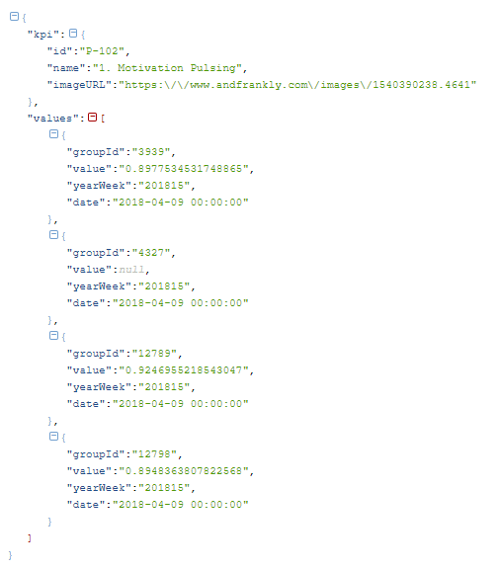

The groupKpi service does not return any values for 16394.

&frankly.description, CSM FTW.description, Marketing.description

These values are not in the <https://data.api.andfrankly.com/v1/groups> service response

